**Task 7 – Simple Calculator**

**Algorithm**• Use prompt() to get two numeric inputs (can be decimal).

• Use prompt() to get the operator: +, -, *, or /.

• Convert number inputs to type Number.

• Use if-else-if-else to perform the selected operation.

• Before division, check if the second number is zero.

• Display input and result using both console.log() and alert().

**Psudocode**

START

PROMPT for first number

PROMPT for second number

PROMPT for operator

CONVERT numbers

IF operator is +

CALCULATE sum

ELSE IF operator is -

CALCULATE difference

ELSE IF operator is *

CALCULATE product

ELSE IF operator is /

IF second number is 0

DISPLAY "Division by zero error"

ELSE

CALCULATE division

ELSE

DISPLAY "Invalid operator"

DISPLAY result

END

**Code(javascript)**

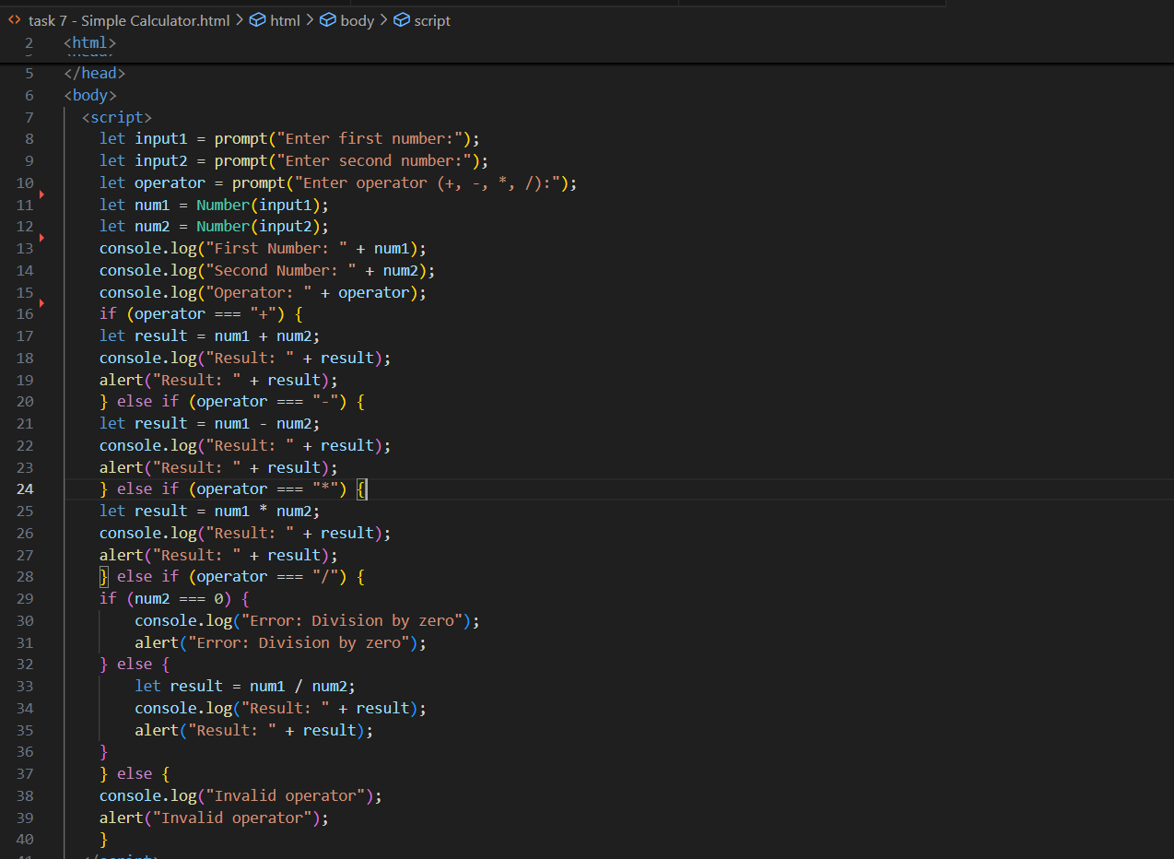

**Output (test case 1)**

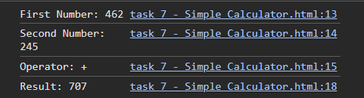

**Output (test case 2)**

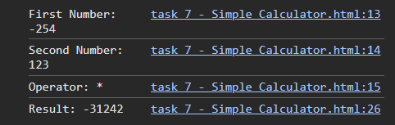  
  
**Output (test case 3)**

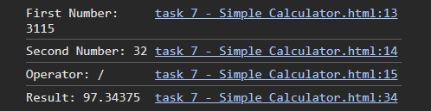

**Observations**

• This program shows how to combine multiple conditions using if-else-if.

• Handles **user input**, **basic math**, and **input validation** (division by zero).

• Input and result are displayed clearly for easy testing and debugging.

• A practical and hands-on task to understand multi-branch decision-making and error handling.